# Content Management System

SUBMITTED IN FULLIMENT OF PROJECT TRAINEE PROGRAM

TO

SCIENTIFIC INFORMATION RESOURCE DIVISION

AT

## BHABHA ATOMIC RESEARCH CENTER, TROMBAY

BY

**Prathamesh Vaidya**

**Aditi Satam**

**Vivek Singh**

UNDER THE GUIDANCE OF

## Shri Ajith Balan & Shri Dattaram

(Scientific Information Resource Division)



## BHABHA ATOMIC RESEARCH CENTER, TROMBAY

**2nd June 2024 – 6th July 2024**

SCIENTIFIC INFORMATION RESOURCE DIVISION

## BHABHA ATOMIC RESEARCH CENTER, TROMBAY

**CERTIFICATE**

This is to certify that.

Master Prathamesh Vaidya

Miss Aditi Satam

Master Vivek Singh

Have satisfactorily carried out Project work titled “Content Management System**”** in fulfilment of the Project Trainee Program at the Scientific Information Resource Division, BARC in the duration 2nd June 2024 – 6th July 2024 .

Shri Manoj Singh  
Head  
Scientific Information Resource Division, BARC

**Date: 06/07/2024**

## DECLARATION

I declare that this written submission represents my ideas in my own words and where other’s Ideas or words have been included, I have adequately cited and referenced the original sources.

I also declare that I have adhered to all the principles of academic honesty and integrity and have not misrepresented or fabricated or falsified any idea/data/fact/source in my submission.

I understand that any violation of the above will be cause for disciplinary action and can also evoke penal action from the sources which thus have not been properly cited or from whom proper permission has not been taken when needed.

Prathamesh Vaidya -------------------------------

Aditi Satam -------------------------------

Vivek Singh -------------------------------

Date: 06//07/2024

## TABLE OF CONTENTS

|  |  |  |
| --- | --- | --- |
| **SR.NO** | **TOPIC** | **PAGE NO.** |
| A. | LIST OF FIGURES | i |
| B. | ACKNOWLEDGEMENT | ii |
| 1. | INTRODUCTION TO CONTENT MANAGEMENT SYSTEM | iii |
| 2. | PROBLEM STATEMENT   * 1. Background   2. Objectives   3. Requirements | iv |
| 3. | FEATURES OF SARASWATI CMS | v |
| 4. | WORKING OF CMS | vi |
| 5. | CONCLUSION | 19 |
| 6. | REFERENCES |  |
|  |  |  |

**LIST OF FIGURES**

|  |  |  |
| --- | --- | --- |
| **SR NO.** | **FIGURE CAPTION** | **PAGE NO.** |
| 1 | CMS Platforms Online | 3 |
| 2 | Common Content Management System | 5 |
| 3 | Working of CMS | 6 |
| 4.2.3 | Pin Diagram of LCD Display | 9 |
| 4.2.4 | LCD Display 2*16 | 9 |
| 4.2.5 | Male-Male Connection Pins | 9 |
| 4.2.6 | Potentiometer | 9 |

## Acknowledgment

We would like to place on record our deep sense of gratitude to our project guide **Shri Ajith Balan** for providing us time-to-time assistance with an environment to achieve goals of our project and supporting us constantly.

We express our sincere gratitude to **Shri Manoj Singh**, Head SIRD, BARC for encouragement and facilities provided to us.

We express our sincere appreciation to **Shri Dattaram**, SIRD, BARC, for his valuable guidance, assistance, and insightful suggestions.

We would also like to thank the entire Scientific Information Resource Division staff who have willingly cooperated with us in resolving our queries and providing us all the required facilities on time.

Prathamesh Vaidya -------------------------------

Aditi Satam -------------------------------

Vivek Singh -------------------------------

Date: 06/07/2024

## INTRODUCTION TO CONTENT MANAGEMENT SYSTEM

A Content Management System (CMS) is a robust software application designed to streamline the creation, management, and publishing of digital content on the web. It provides individuals and organizations with powerful tools to efficiently handle the entire content lifecycle, from creation and editing to storage, distribution, and archival.

CMS platforms serve as the backbone of websites, intranets, blogs, and various digital applications by offering intuitive interfaces that simplify complex tasks traditionally associated with web development and content management. They enable users, regardless of technical expertise, to create and manage diverse content types such as text, images, videos, documents, and interactive elements.

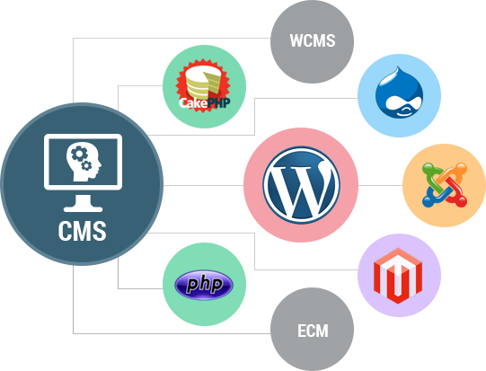

Fig 1 : CMS Platforms Online

Currently, there are numerous content management systems available in the market catering to various applications. However, there is a distinct need for a customized CMS that seamlessly integrates with SARASWATI, BARC's dedicated intranet information platform which lead to our problem statement.

## PROBLEM STATEMENT

Problem Statement for CMS System for Saraswati Website

1. Background

The Saraswati website features an essential section known as "SIR Bulletin" which provides important updates and information. This section requires frequent updates and the ability to add new content monthly or bi-monthly, depending on changing organizational needs. To manage this efficiently, a robust Content Management System (CMS) is necessary.

1. Objectives

Content Management : Enable the creation, editing, and updating of the "SIR Bulletin" section on a regular basis, with flexibility to adjust the frequency of updates as needed.

User Management : Allow for the assignment of different user roles, including Admin users and regular users with limited privileges which can be revoked at any future instance. Each user shall have secure credentials and all activities of the user should be logged.

1. Requirements

i. User Roles and Permissions :

- Admin users should have the ability to:

- Edit and update the "IRB Positive" section.

- Assign roles to other users.

- Manage regular users' permissions.

- Regular users should have limited access, primarily for viewing content and, if necessary, making minor edits.

ii. Scalability :

- The CMS should be designed to handle potential increases in content volume and user activity without compromising performance.

iii. Usability :

- The system should be user-friendly, with an intuitive interface for both Admin and regular users.

- Provide clear documentation and support to assist users in managing the "SIR Bulletin" section effectively.

## Feature of SARASWATI CMS

• **Content Creation and Editing:** Our CMS platform features a WYSIWYG (What You See Is What You Get) editor, allowing content creators to draft and edit content directly within the system. This provides the user a better understanding of how the changes made will be reflected on the actual website.

• **Content Organization and Structuring:** CMS provide robust capabilities for organizing content through categorization in data tables and allowing multitude of search functions. This helps maintain a logical structure and facilitates easy navigation for users browsing the CMS.

• **User Management and Permissions:** our CMS platform offers sophisticated user management functionalities, including role-based access control (RBAC). Administrators can define user roles with specific permissions, ensuring that only authorized individuals can add, update users who in turn create, edit, or publish content.

• **Responsive Design:** Modern CMS prioritizes responsive design, ensuring that the system will provide optimal viewing experiences across devices and give prompt at each step of error or success for better user understanding. This is crucial in today's digital landscape.

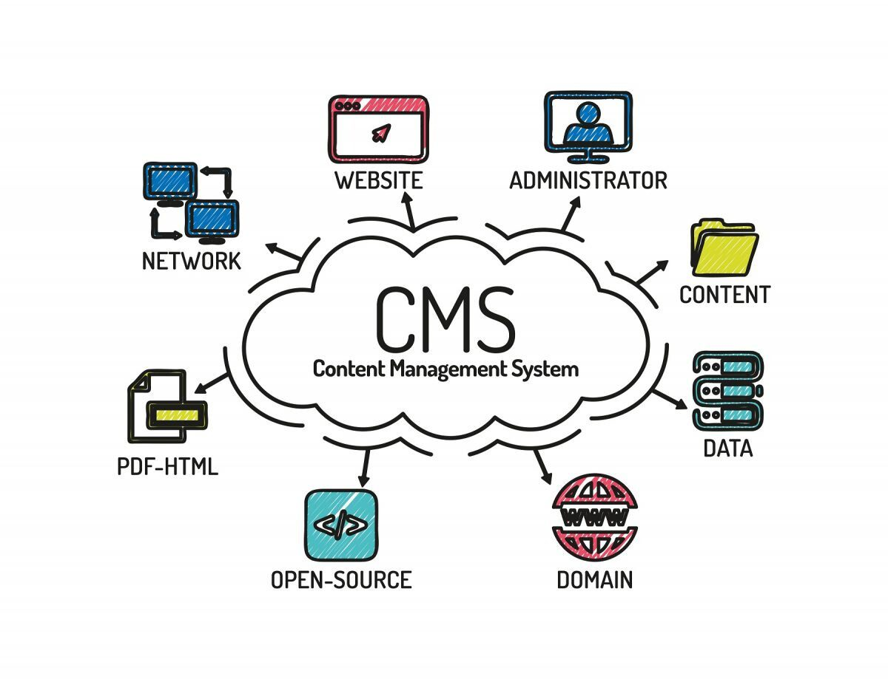

Fig 2 : Common Content Management System Features

## Working of SARASWATI CMS

Diagrammatic representation of working or our CMS

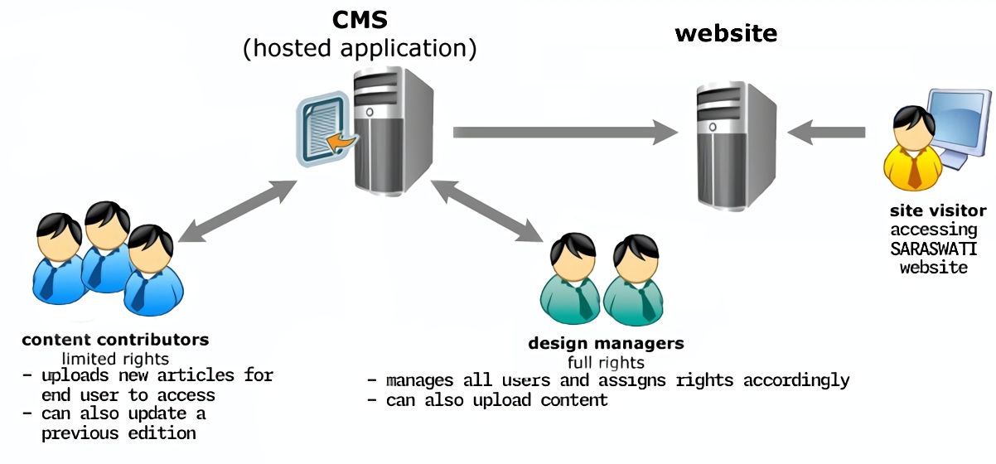

Fig 3 : Working of CMS

Let us understand the working of our created CMS with the following pictorial guide:

## CONCLUSION

Implementing a CMS for the Saraswati website's "SIR Bulletin" section will streamline content updates, ensure flexibility in content management, and maintain a structured user management system, ultimately contributing to the website's overall effectiveness and user engagement.

1. **Scope , features khalche, literature review/ survey, future scope, references**
2. **INTRODUCTION TO HR MONITORING SYSTEM**

### Problem Definition

Existing heart rate monitoring systems lack the necessary balance of affordability, accuracy, and user-friendliness required for widespread adoption in both clinical and personal settings. These systems often suffer from issues such as inadequate accuracy, bulky designs, and a lack of real-time monitoring capabilities. Additionally, they often fail to integrate seamlessly with other health- tracking platforms, limiting their ability to provide comprehensive health insights. Therefore, there is a critical need to develop a cost-effective, accurate, and user-friendly heart rate monitoring system that offers real-time monitoring and seamless integration with existing health-tracking technologies.

### Aims and Objectives

Aims:

* + - To develop a reliable and accurate heart rate monitoring system.
    - To create a user-friendly interface for easy interaction and interpretation of heart rate data.
    - To ensure real-time monitoring capabilities for timely intervention in case of abnormalities.
    - To optimize the system's portability and comfort for long-term use.
    - To integrate wireless communication protocols for seamless data transmission.
    - To comply with relevant medical standards and regulations for safety and reliability. Objectives:
    - Design and implement signal processing algorithms to accurately measure heart rate.
    - Develop a compact and lightweight hardware design for portability.
    - Create an intuitive user interface for displaying heart rate data.
    - Conduct rigorous testing to evaluate accuracy, reliability, and usability.

### Scope

The scope of a project for a Heart rate monitoring system will depend on the specific requirements and goals of the project. However, generally, the scope of such a project would include:

1. Functionality: The system will continuously monitor heart rate in real-time and provide accurate readings to users.
2. Portability: The device will be designed to be lightweight, compact, and comfortable for users to wear during various activitie
3. User Interface: An intuitive and user-friendly interface will be developed to display heart rate data clearly and understandably.
4. Real-time Monitoring: The system will offer instant feedback on heart rate fluctuations, enabling users to take timely action if necessary.
5. Future Expansion: Consideration will be given to potential future enhancements and upgrades to improve the functionality and effectiveness of the system over time.

### Features of The Project

The features of a project for Smart Floor Cleaning Robot will depend on the specific requirements and objectives of the project. However, typical features of such a project might include:

1. Accurate Heart Rate Measurement: Reliable sensors and algorithms ensure precise readings.
2. Real-time Monitoring: Continuous updates on heart rate during various activities.
3. Comfort and Wearability: Ergonomic design for comfort during prolonged use, including water resistance for versatile use.
4. Data Storage and Analysis: Tracks heart rate over time for progress monitoring and goal setting.
5. Battery Life: Long battery life ensures that the device can sustain continuous monitoring for extended periods without frequent recharging or battery replacement
6. Heart Rate Broadcasting: Advanced HRM systems can broadcast heart rate data to compatible fitness equipment, allowing users to monitor their heart rate on gym machines or other compatible devices.

## 5. CONCLUSION & FUTURE SCOPE OF THE PROJECT

### Conclusion:

The development of a reliable and user-friendly heart rate monitoring system is essential to address the shortcomings of existing solutions. This project aims to prioritize accuracy, portability, real-time monitoring, and seamless integration with health platforms. By focusing on user needs and leveraging technology advancements, the system seeks to empower individuals to manage their cardiovascular health effectively. Ongoing refinement and research efforts will ensure optimal performance and meet evolving user demands. Ultimately, the successful implementation of this system can have a significant impact on public health by providing accessible tools for monitoring and promoting overall well-being.

### Future Scope:

* 1. Advanced Sensor Technology: Integration of advanced sensor technologies, such as photoplethysmography (PPG) sensors or electrocardiogram (ECG) sensors, to improve accuracy and provide additional physiological insights.
  2. Health Analytics: Incorporation of machine learning algorithms for predictive analytics, enabling the system to identify patterns and trends in heart rate data to predict and prevent potential health issues.
  3. Wearable Integration: Seamless integration with wearable devices, such as smartwatches or fitness trackers, to enhance user convenience and enable continuous monitoring throughout the day.
  4. Continuous Improvement: Continuous improvement through user feedback and iterative updates to enhance usability, performance, and features based on evolving user needs and technological advancements.

## 6. REFERENCES

1. IEEE Xplore. Available at: https://ieeexplore.ieee.org/Xplore/home.jsp (Accessed: 18 April 2024): [https://ieeexplore.ieee.org/stamp/stamp.jsp?tp=&arnumber=7057005&isnumber=7056912](https://ieeexplore.ieee.org/stamp/stamp.jsp?tp&arnumber=7057005&isnumber=7056912)
2. HTTP IEEEXPLORE - ieee.org stamp stamp - JSP ARNUMBER 01570507 (no date) Scribd. Available at: https:/[/www.scribd.com/doc/49461909/http](http://www.scribd.com/doc/49461909/http-ieeexplore-ieee-org-stamp-stamp-jsp-)-[ieeexplore-ieee-org-stamp-stamp-jsp-](http://www.scribd.com/doc/49461909/http-ieeexplore-ieee-org-stamp-stamp-jsp-) arnumber-01570507 (Accessed: 18 April 2024): <https://doi.org/10.1080/02701367.2000.11082782>
3. Bandana Mallick1 Ajit Kumar Patro, “Heart Rate Monitoring System using finger tip through arduino and processing software” International Journal of Science, Engineering and Technology Research (IJSETR), Volume 5, Issue 1, January 2019 Available : [IJSETR-VOL-5-ISSUE-1-84-89-libre.pdf (d1wqtxts1xzle7.cloudfront.net)](https://d1wqtxts1xzle7.cloudfront.net/51881156/IJSETR-VOL-5-ISSUE-1-84-89-libre.pdf?1487670923=&response-content-disposition=inline%3B+filename%3DHEART_RATE_MONITORING_SYSTEM_USING_FINGE.pdf&Expires=1714451745&Signature=PWR1HVev03KwY2GKFl54CxH5EygI4znszgAgFvs~B8rfawfn7RZ22kaBvE~fCddNYkrVzDtRF6Aht8oklFp7q-tEDBt2O6wCb1FkqFEru4jkh0lxYs5a0Lh65IcqQ2MYGog6dQW5F3xvdrhtyMpLGTrVKSXHSjTwUG9GySVofo~nOx52yT2tyKA-74WMzlVlUWFvsFx4SQSSDfXQpDQi4vDDlXryYBGbju~Hmh6gbgis~wL8CVsassz2Jk9nIGahGRlnmcn1oiK5igI-EjOR7mS9tejAKXJsnbqWrSd8CxM0MrfFLiEQ076526id~n4LhiHE8SbTB7or7kRNefk48w__&Key-Pair-Id=APKAJLOHF5GGSLRBV4ZA)